**Session report 06 /12/2022:**

*LABAUVIE – RAFFAELLI EVA*

*ROB3*

For today’s session I tried the laser detecting device for Arduino.

I started searching for the right way to plug it correctly.

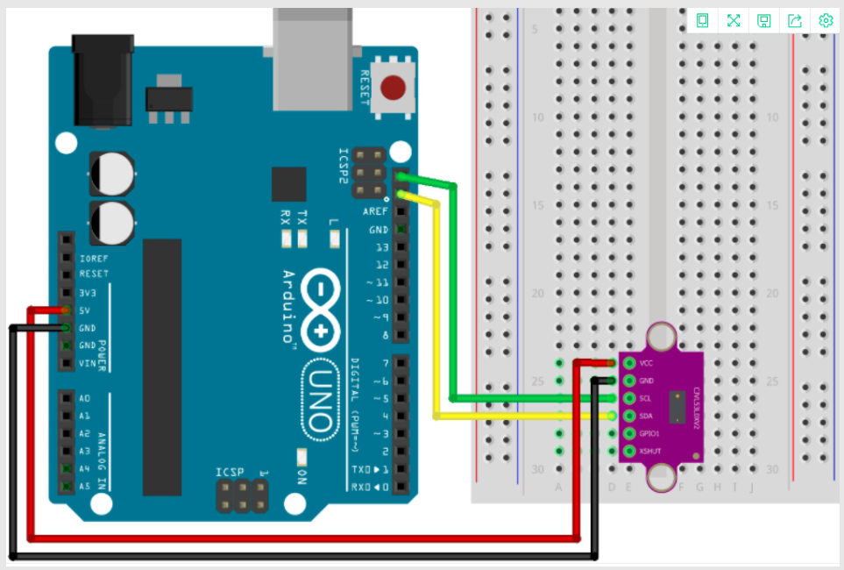

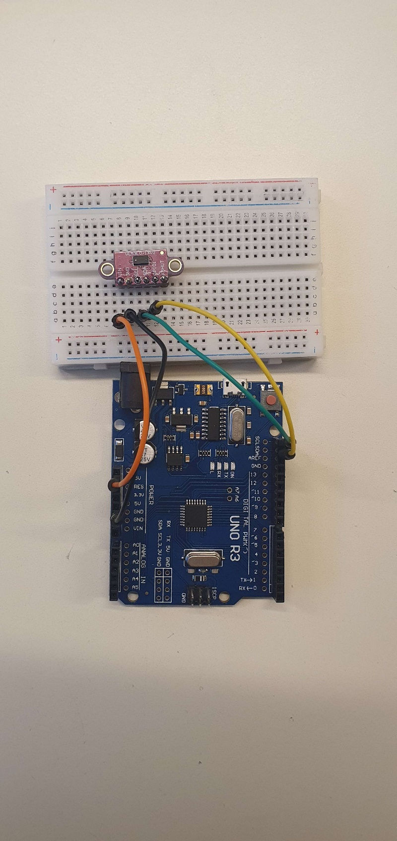

I had to install the Adafruit library to read the sensor’s data.

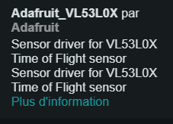

Le laser semble fonctionner, il est précis.

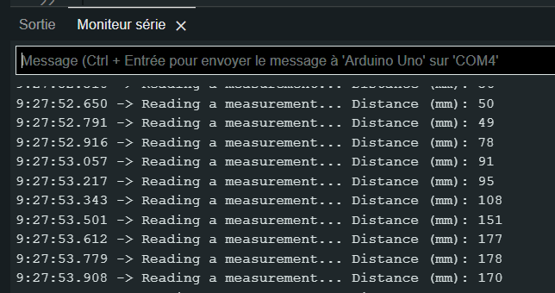

Then Hugo tried to combine the laser detector with his motors code to make the wheels turn so we can ask the robot to stop and turn if there’s an obstacle in front of him.

Next, I decided to start trying to model the sorting device.